高雄囝仔的文史保存建議書

高雄市苓洲國民小學

盧彥玹、姚博維、劉晉函、金子倫也、姜閔傑、林純華
翁菀羚、楊念芯、張玲華、童奕竣、高于涵、呂佳薇、洪品涵

中華民國103年1月20日

Recommendations
We are a group of students from Ling Jhou Primary School. This year we attended the competition of “2014 Taiwan School Cyberfair”. We did the research on Hsu Sheng-Ming coach. We made a project by questionnaire survey, interview, and field investigation. We hoped the public could reference our opinions. Make Taiwan baseball better!
【Schedule】
- 102.09.25 (WEN) Visit Hamasen. Have a walk at ShinBin Street.
- 102.10.02 (WEN) Search reports about ShinBin Street.
- 102.10.16 (WEN) Visit famous attractions in Hamesen.(Follow the map)
- 102.10.30 (WEN) Search data about TAKAOBOOKS” bookstore.
- 102.11.13 (WEN) Shoreline Remembrance-The book is written about Hamasen.
- 102.12.11 (WEN) Interview with the director-general of Takao Renaissance Association, Mr. Xie.
- 102.12.15 (SUN) 1. Take participate in woodworking classes on Sunday, organized by the Association.
2. Attend House-made activities in Namasia.
- 102.12.18 (WEN) Make poster of buildings in ShinBin Street.
- 102.12.25 (WEN) Interview with manager of TAKAOBOOKS” bookstore, Mr. Chung.
- 102.12.25 (WEN) Interview with the chairman of Takao Renaissance Association, Mr. Guo.
- 102.12.25 (WEN) Interview with the elders in Hamasen.
- 103.01.08 (WEN) Hamasen filming
1. Sasaki Shop.
2. Hifumitei Ryotei (Japanese Restauant)
3. Distributing Store of Meiji Seika
4. Hontoukan Ryokan (Japanese Inn)
- 103.01.16 (THU) “Hamasen Activity” presentation.
- 103.01.16 (THU) “Hamasen Activity” press conference
- 103.01.20 (MON) Recording “Multinational debating club” video
- 103.02.12 (WEN) Collate survey information to Kaohsiung government.
- 103.03.06 (THU) Public lucky. Draw a person to win a painting.

- Conclusions and recommendations
- Up to 98% of the respondents know “TAKAO” is the old name of Kaohsiung, but less people know the history of Hamasen and the demolished event. The government and the association should spread it louder, and hold more local activities, making more people to know Hamasen.
- Most of the respondents support historical relics should be well preserved, and respect cultural workers. We will share information to the public to support the activity of preserving Kaohsiung culture.
Hamasen questionnaire survey. Result and Analysis
I. Analysis of the questionnaire
1. Do you live in Kaohsiung?
Kaohsiung | Taipei | Northern part | Central | Southern part | East part
71 | 8 | 6 | 7 | 16 | 6

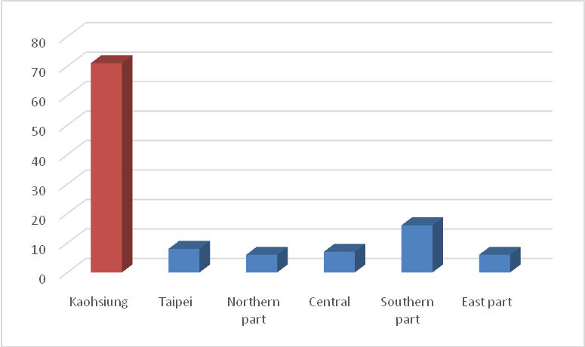

2. What’s your purpose about coming here?
Passing | Tourist | Business | Dine | Other
18 | 68 | 6 | 21 | 18

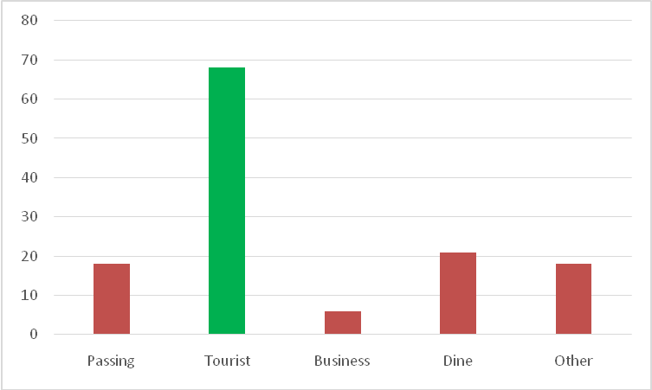
3. Do you know the old name of Kaohsiung, “Takao”?
Yes | No
127 | 4

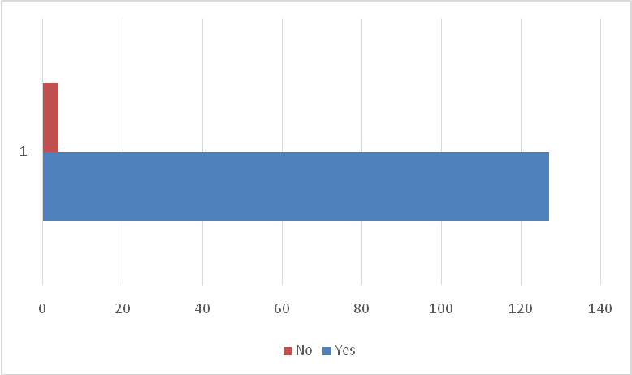

4. Do you know “Hamasen” is the old name of this area?
Yes | No
73 | 56

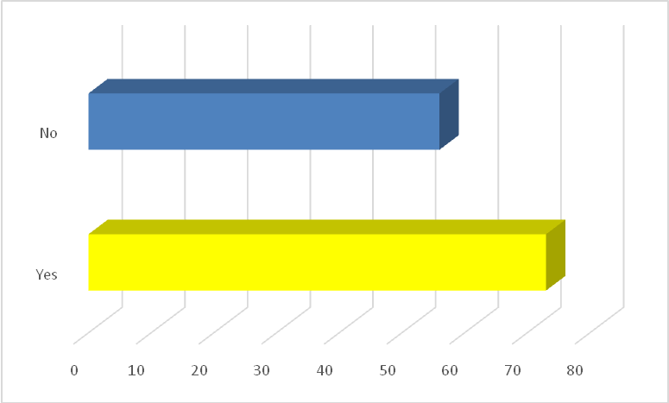

5. Do you know the origin of “Hamasen”?
Yes | No
34 | 49
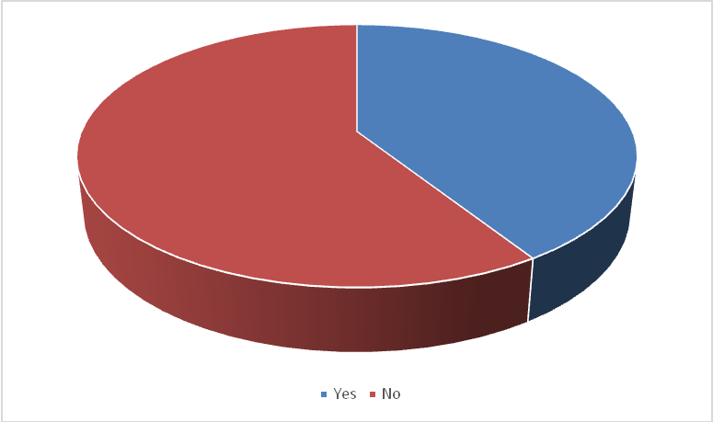

6. Do you know the old community in here has faced the fate of being demolished?
Yes | No
52 | 77

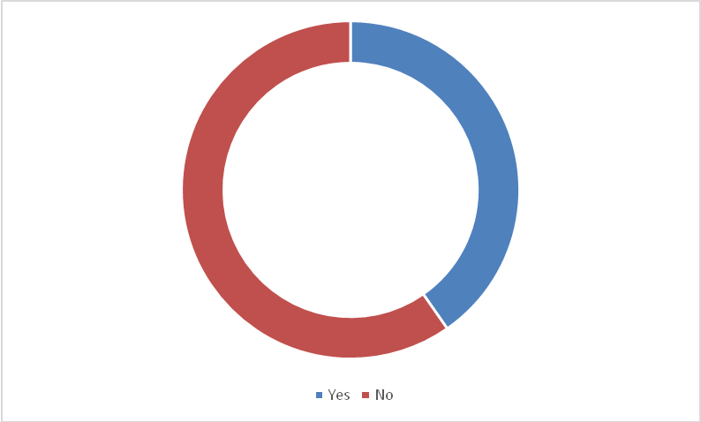

7. What is your opinion?
Approved | Disapproved
3 | 123
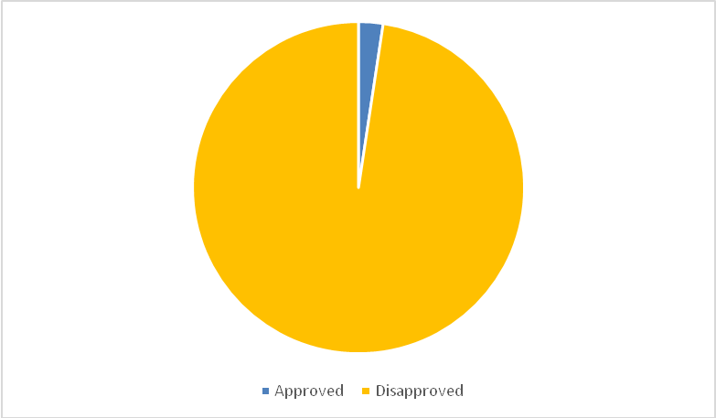

8. What is your attitude that if you know there is a group hardly preserving the old history and culture of Kaohsiung?
Approved | Disapproved | No comments
118 | 1 | 11

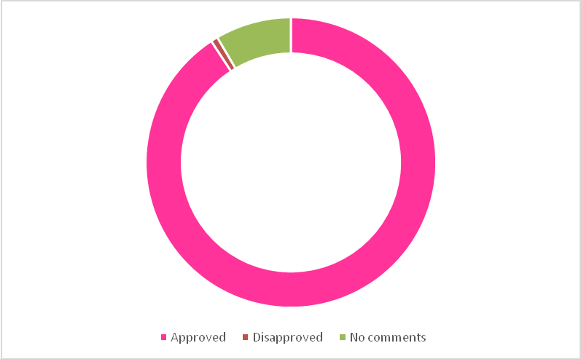

9. If you have opportunity to attend the activity of “Preserve the culture of Kaohsiung”, which way you prefer?
Money sponsor | Volunteers | Share information | Other
19 | 45 | 111 | 3

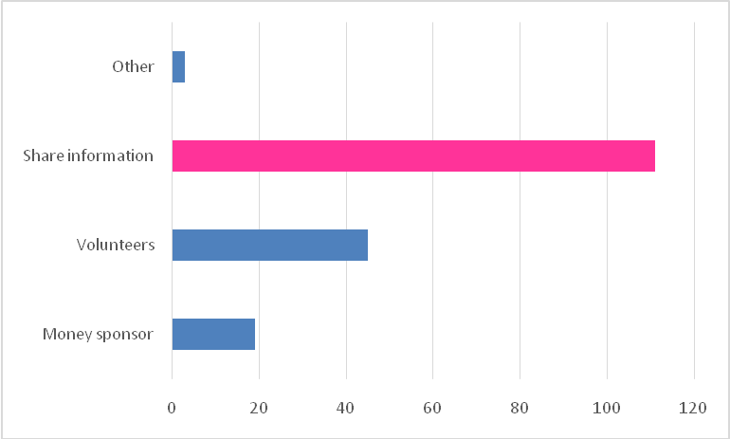

10. If there is a campaign similar to the "Preserved Kaohsiung old culture", Presented in which way would attract you to participate?
Exhibition | Lectures | Camp | Publication of books | Open craft courses | Others
86 | 39 | 26 | 25 | 36 | 3
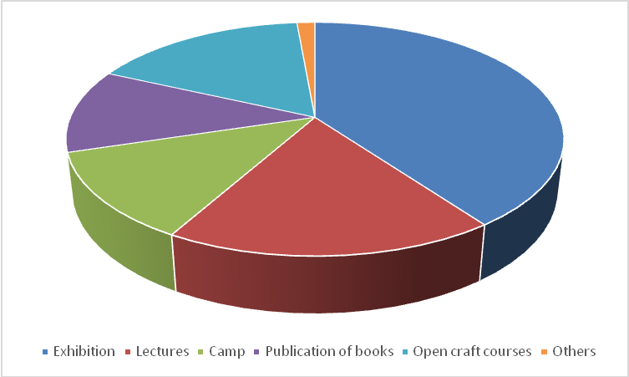
10.Do you have any advice for the activity of “Preserve Hamasen Traditional Culture”？
- It is not easy to develop cultural and creative industry in Taiwan. Go!
- Let’s teach the next generations where our ancestors came from.
- The culture should be preserved.
- We can do promotion on the Internet and publicize campaigns by media.
- Diversification, constructive and sustainable business.
- Keep up the good job.
- I hope it can be preserved. Don’t like HongMaoGang which had faced demolition. Although it has become cultural park, we cannot see the old constructions anymore. That harms the locals.
- Development does not have to dismantle monuments. We can save it.
- The community may attend the activities positively.
- I support it! The public sector should concern it.
- Set up fan page on Facebook.

II. Gender ratio of respondents
 | Male | Female | Total
Number of people | 55 | 75 | 130
Ratio | 42% | 58% | 100%

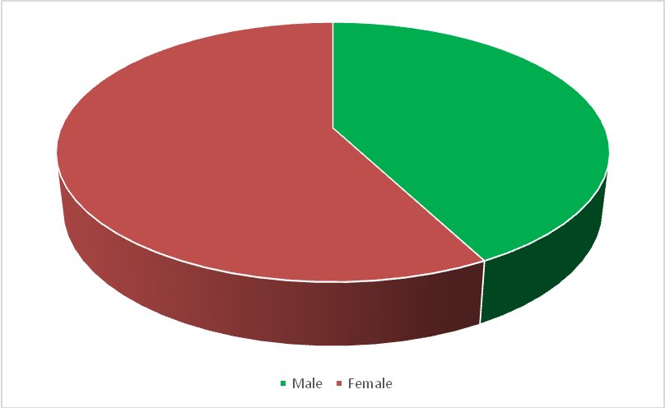

III. Statistics of respondents aged
 | Under 20 | 20~29 | 30~39 | 40~49 | 50~59 | 60 or more | Total
Number of people | 41 | 45 | 16 | 12 | 13 | 3 | 130
Ratio | 32% | 35% | 12% | 9% | 10% | 2% | 100%

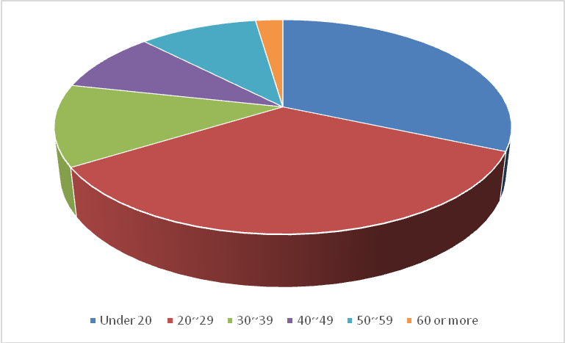
IV. Respondents’ level of education
 | Primary school | Junior high school | Senior high school | College | Master and above | Other | Total
Number of people | 6 | 0 | 27 | 84 | 11 | 1 | 130
Ratio | 5% | 0% | 21% | 65% | 8% | 1% | 100%
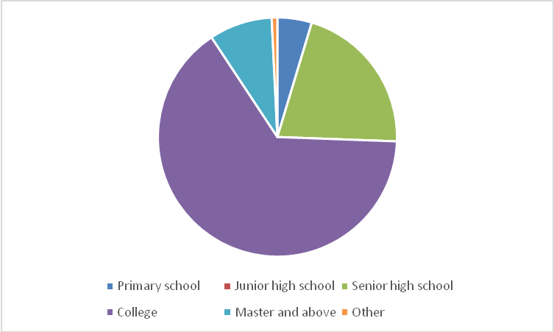
V. Respondents’ career
 | Realestate | Military | Public | Education | Labor | Business | Medical | Social work | Self-employed | Housekeeper | Students | Unemployed | Other
Times | 0 | 3 | 3 | 7 | 12 | 18 | 1 | 9 | 7 | 5 | 57 | 1 | 8

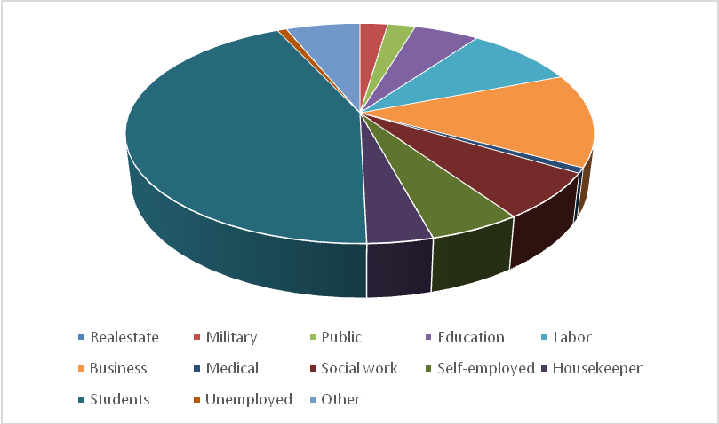
- Result and analysis
This survey is finished by Ling Jhou Primary School in December, 2013. We did survey on 130 tourists who visited Hamasen.
Statistical information is as follows:
- There are 55 male respondents (42%), 75 female respondents (58%), and the respondents mainly aged 20-29 (40%).
There are 84 respondents educated to college (65%), 27 respondents educated to senior high school (21%). The respondents are mainly students (57 people, 43%).
(2) Up to 98% of the respondents know “TAKAO” is the old name of Kaohsiung, but less people know the history of Hamasen and the demolished event. The government and the association should spread it louder, and hold more local activities, making more people to know Hamasen.
(3) Most of the respondents support historical relics should be well preserved, and respect cultural workers. We will share information to the public to support the activity of preserving Kaohsiung culture.
(4) We advise Takao Renaissance Association to hold more exhibitions, lectures and technology courses (woodworking class).

